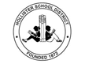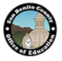

Teacher Arts Workshops
3 PD units available for only $62 each unit!

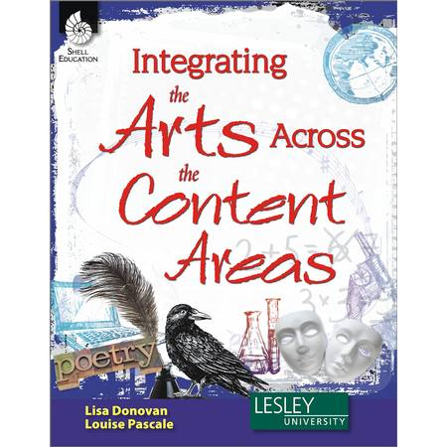
Integrating the Arts Across the Content Areas
In this series of 7 workshops, teachers will: learn how to incorporate the arts into their everyday curriculum while meeting the Core Standards, collaborate with other teachers on Arts Integration and use the provided textbook to develop new ideas and create practical, easy-to-use lesson plans. Workshops will be part lecture/discussion and part hands-on activities. Come ready to learn & create!
Participants describe the workshops as “Enlightening, useful, and invigorating.”

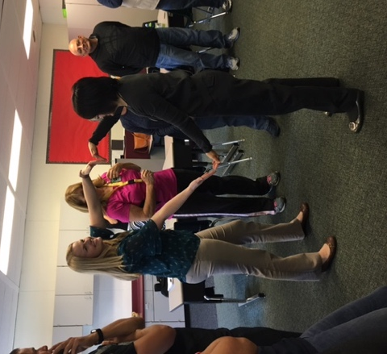
Workshops will be held at Cerra Vista Elementary

on the third Thursdays from 3:45-5:45

10/19 Visual Arts
11/16 Art & Technology
1/18 Music
2/15 Poetry & Theatre
3/15 Storytelling
4/19 Dance & Movement
5/17 Visiting Artist

Previous Presenters have included: Robert Kikuchi Yngojo of Eth-Noh-Tec, Mino Valdez of El Teatro Campesino, Paula Bliss of Tandy Beal and Company, Destiny Arts of Oakland and Ian Slattery of the Community Media Access Partnership (CMAP).
Robin McGinnis, lead workshop facilitator, holds a multiple subject teaching credential and a BFA and MFA in Art from San Jose State. She has over 20 years of experience teaching college and high school art students and elementary school children using art methods as well as teaching art skills and techniques.

Register at sanbenito.k12oms.org

$10.00 per session
These workshops are being offered by the San Benito County Arts Council in collaboration with the San Benito County Office of Education and the Hollister School District.
For more information, please contact the San Benito County Arts Council
831.636.2787 www.sanbenitoarts.org info@sanbenitoarts.org

